**Project Summary**

**Audience:**

We are representing the research and analytics team of an American insurance company, Happy Insurance Partners (HIP) Inc., headquartered in College Park, Maryland looking to expand its business to a new region outside the United States. The presentation is a proposal of our data driven research and is being presented to the board of directors at HIP for whom the research was conducted.

**Target:**

The analysis of data is being conducted to find out an investment destination for our insurance company to expand its business. The company is really reserved with its investments and wants to make sure that the investment has to be safe with a good appreciation in the next decade.

**Source Data**

Team HIP will be analyzing the World Development Report 2014 which is compiled by the World Bank. It consists of data aggregated from various sources which comprises of 75 indicators that are relevant to the management of risk in the context of development. The report consists of large amount of data from demography, natural disasters, education and income which makes it favorable to be analyzed for a global insurance service provider.

The World Bank, World Development Report 2014 (World Development Report, 2016. Wdr2014-annex-tables.csv [Data set CSV File]. Retrieved from http://data.worldbank.org/data-catalog/world-development-report-2014. September 22nd, 2016.)

**Processing**

The dataset contained a lot of information that was irrelevant to our research question in addition to null values. We started with the data cleaning process prior to our analysis. The initial analysis such as central tendency and histograms were carried out in R. Additionally, the filtering of top 10 countries and its plotting was also done in R. As we advanced with our work, we used Tableau for the purpose of better visual representation and quicker analysis.

**Plots & Interpretation**

We used different types of visualizations in Tableau to represent our data in the best possible way. Our main focus was to identify the top ten country where we can expand our business to and analyzed this using the macro-economic factors. We plotted attributes like Gross Domestic Product, Purchasing Power Parity and International Reserves which are clear indicators. This is our justifications about how the top 10 countries regarding the three macroeconomic factors (GDP per capita growth rate, Gross National Income, International Reserves) were chosen.

1.      List all the countries which are within the top 10 regarding at least one of the macroeconomic indicators (GDP per capita growth rate, Gross National Income, International Reserves).

The listed countries are: United States, China, India, Japan, Germany, Russian Federation, France, United Kingdom, Brazil, Sierra Leone, Turkmenistan, Sri Lanka, Panama, Liberia, Cote d'Ivoire, Armenia, Niger, Burkina Faso, Hong Kong SAR, Lebanon, Singapore, Switzerland, Thailand, Bolivia, Malaysia, Algeria, Saudi Arabia, Syrian Arab Rep, Yemen, Jordan.

2.      Remove United States because our company is based in U.S. and our goal is looking for foreign investment opportunities.

The remaining countries are: China, India, Japan, Germany, Russian Federation, France, United Kingdom, Brazil, Sierra Leone, Turkmenistan, Sri Lanka, Panama, Liberia, Côte d'Ivoire, Armenia, Niger, Burkina Faso, Hong Kong SAR, Lebanon, Singapore, Switzerland, Thailand, Bolivia, Malaysia, Algeria, Saudi Arabia, Syrian Arab Rep, Yemen, Jordan.

3.      Remove the countries which GDP per capita growth rate is negative. A negative GDP per capita growth rate indicates each person within the countries produces less goods and services, thus people receive less payment and will consume less. We only want to invest in strong and productive economic entities which guarantee profitable returns because we are very conservative about our investment assets.

The remaining countries are: China, India, Japan, Russian, Federation, Saudi Arabia, Thailand, Malaysia, Syrian Arab Rep, Sri Lanka, Panama, Bolivia, Turkmenistan, Côte d'Ivoire, Germany, Burkina Faso, Armenia, Niger, Sierra Leone, Liberia, Algeria, Jordan, Lebanon, Hong Kong SAR, Brazil.

4.      Remove Turkmenistan. Turkmenistan’s international reserves values are unavailable from the World Bank dataset, which raises a red flag. The country may not have sufficient number of external assets such as dollars, euros, gold to stabilize the domestic market in potential extreme conditions.

The remaining countries are: China, India, Japan, Russian, Federation, Saudi Arabia, Thailand, Malaysia, Syrian Arab Rep, Sri Lanka, Panama, Bolivia, Cote d'Ivoire, Germany, Burkina Faso, Armenia, Niger, Sierra Leone, Liberia, Algeria, Jordan, Lebanon, Hong Kong SAR, Brazil.

5.      Remove Syrian Arab Republic. The country has lost more than one third of its international reserves between 2005-2007 and 2010-2012 period. Such incident suggests the country’s economic is bleeding, and it is mostly likely due to the ongoing civil war which took place in 2011.

The remaining countries are: China, India, Japan, Russian, Federation, Saudi Arabia, Thailand, Malaysia, Sri Lanka, Panama, Bolivia, Cote d'Ivoire, Germany, Burkina Faso, Armenia, Niger, Sierra Leone, Liberia, Algeria, Jordan, Lebanon, Hong Kong SAR, Brazil.

6.      Remove the countries have Gross National Income (adjusted against purchasing power parity rates) less than 300 (in $billions).

Gross national income (GNI) is the sum of value added by all resident producers plus any product taxes. After being adjusted by purchasing power parity rate, we will able to compare the GNI across countries in a common currency. A higher GNI usually indicates better standards of living and it bodes well for a country.

The remaining countries are: China, India, Japan, Russian Federation, Saudi Arabia, Thailand, Malaysia, Germany, Hong Kong SAR, Brazil.

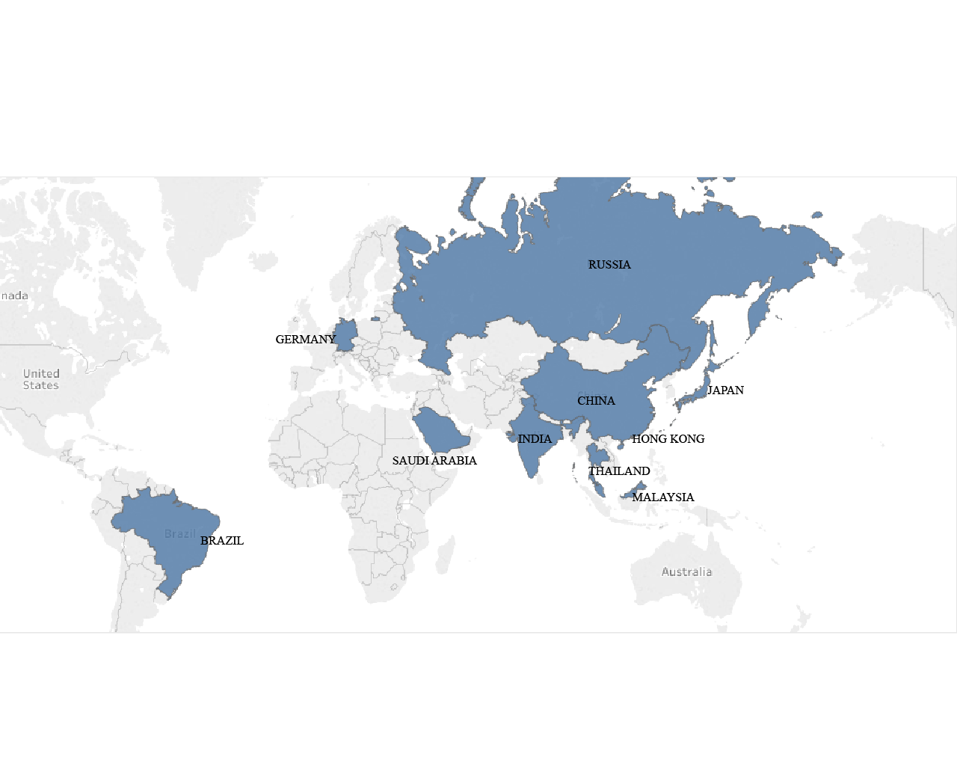

**Decision & Conclusion**

Using the top ten derived, we analyzed each attribute to answer if there was demand and human capital in the countries which were eligible. Based on our Analytics, we identified a ranking which is demonstrated in the below choropleth map. We recommend that HIP expand its services to Japan, Germany and Hong Kong. This decision has been made after closely analyzing if the market is stable, has adequate demand for our services and has the political and human capital resources to ensure success. The first phase of the expansion can take place within the first quarter of 2014 and once we have established a firm base we can run a correlation analysis to expand in similar countries.

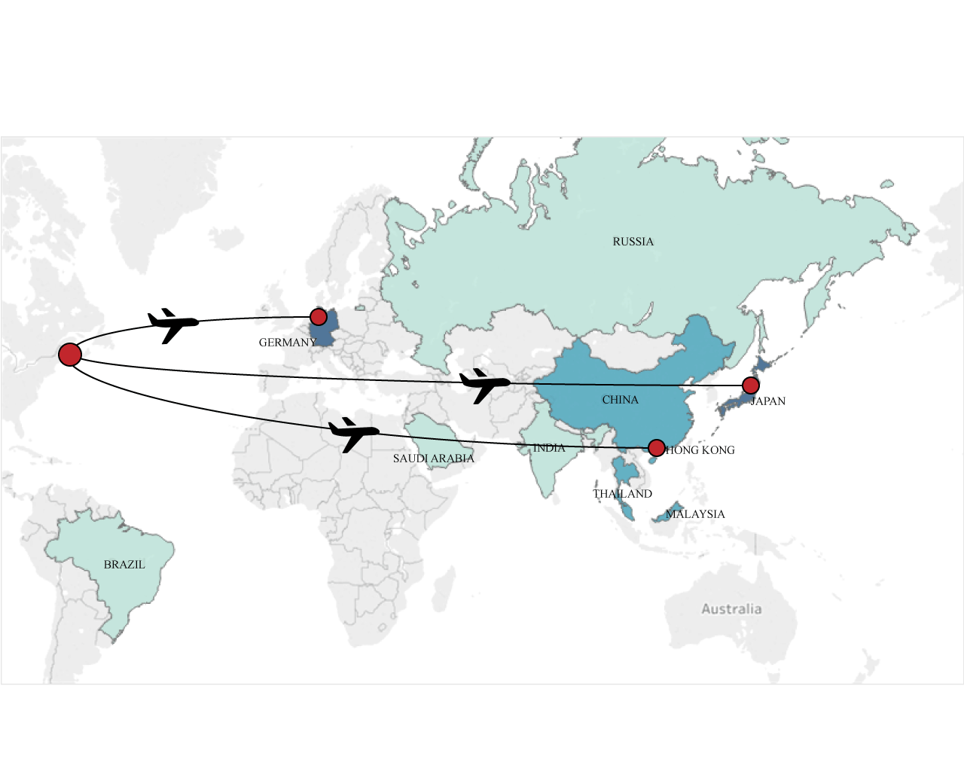

**WORD COUNT: 988**